|  |
| --- |
| National Day Parade Theme Song Compilation |

Over the years, we have heard so many high-spirit, positive and energetic songs when we are approaching the days leading up to Singapore National Day. How many of such songs that you are aware of?

Create an app that lets users input the Songs they have come across. The user will enter some information on a song. It should also have an edit and delete song function.

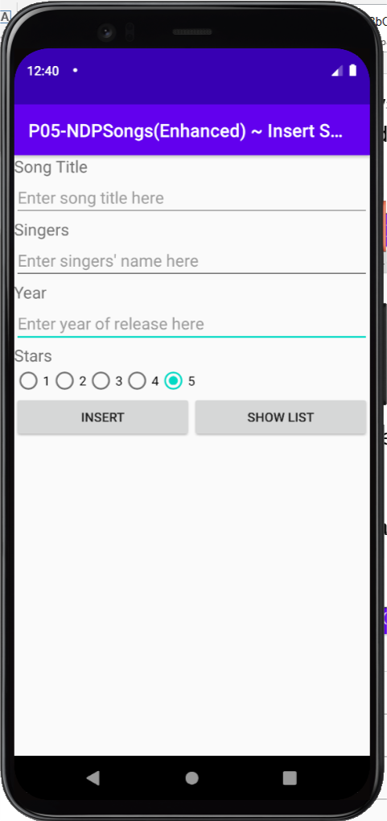 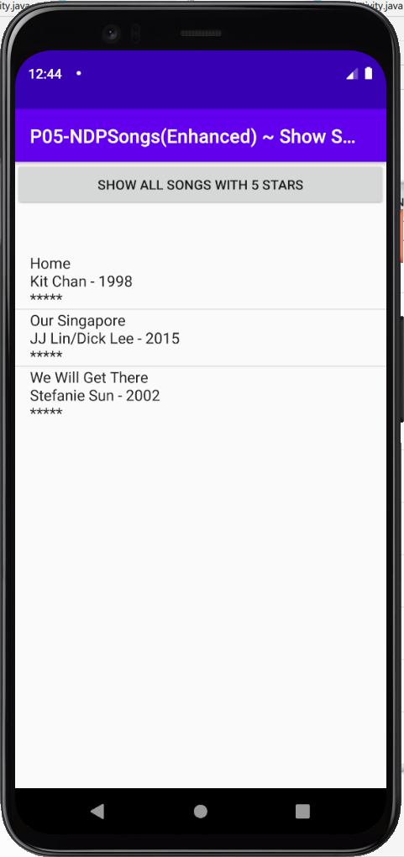 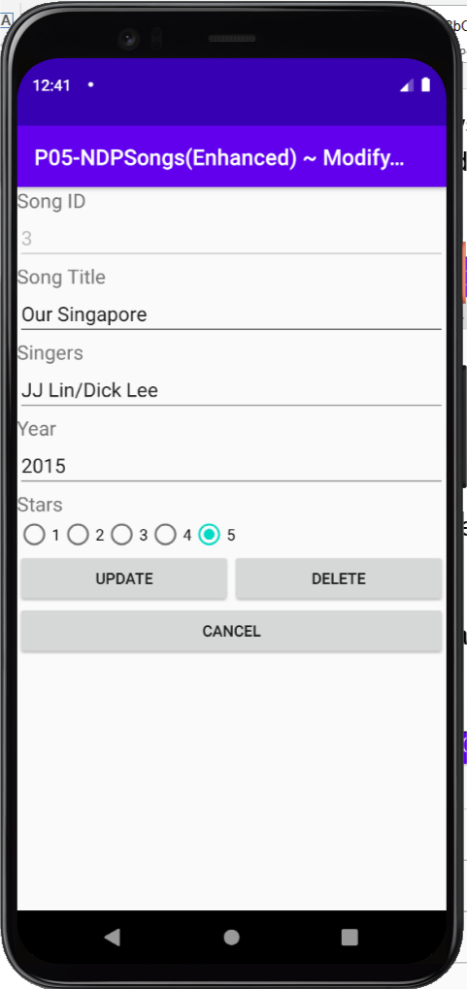

The app should look like the images above with these features

1. The user can insert a song by inputting the title, singers, released year, and rating of 1 to 5 (stars).
2. Clicking the **Insert** button adds the song to the database (with a Toast feedback)
3. Clicking the **Show List** button shows a list of all songs on another activity (Second Activity).
4. Clicking on the **Show All Songs with 5 Stars** button in the Second Activity will show only songs that have 5 stars.
5. Clicking on a particular song in the Second Activity will go to the Third Activity where the user is able to edit/delete that song.
6. When the app returns to the Second Activity, it will refresh the ListView if there’s any database operation performed.

Reference: <https://en.wikipedia.org/wiki/Singapore_National_Day_Parade#Theme_songs>

## Advanced Enhancement

Add a spinner on the Second Activity to let the user choose to retrieve songs by year.

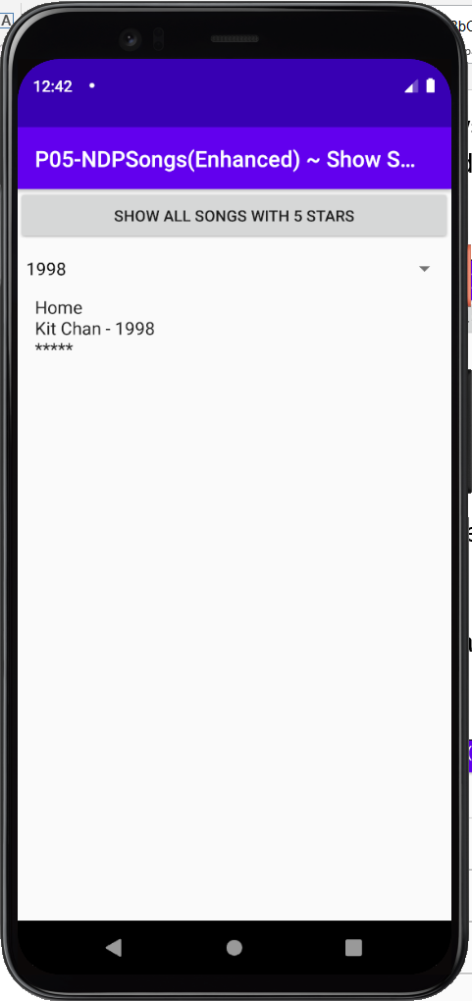 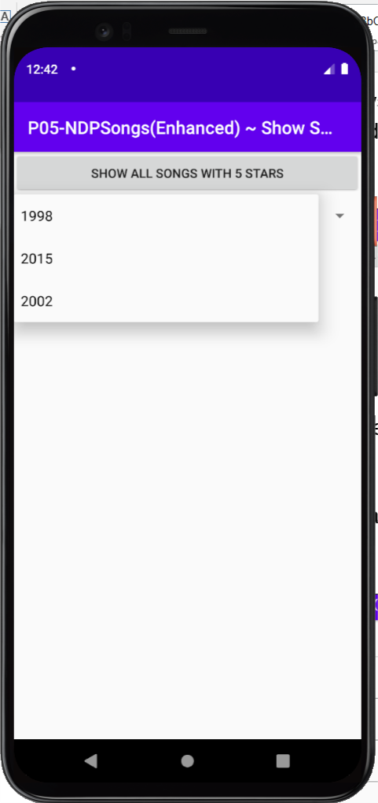 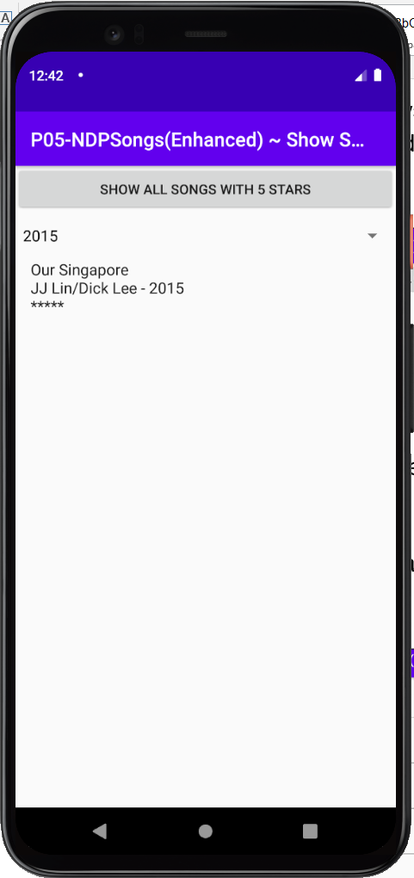

Hints:

1. You may need to retrieve distinctive year entries from the database.

The query for distinct records ([APIdoc](http://developer.android.com/reference/android/database/sqlite/SQLiteDatabase.html) – Look for query)

1. A simple tutorial on Spinner

<http://www.ahotbrew.com/android-dropdown-spinner-example/>